DEALS TO SANTA BARBARA

Beautiful weather, gorgeous scenery and rich history – what’s not to like about Santa Barbara? There’s plenty to do in Santa Barbara during your upcoming trip to this beautiful city on California’s central coast. Book a trip to Santa Barbara via Los Angeles International Airport on Virgin America. Live it up at 35,000 feet with WiFi, on-demand entertainment, and more on every flight.

(MARKET IMAGE HERE)

Find Deals From These Cities

INSERT FARE GRID FROM / TO Version (if available!)

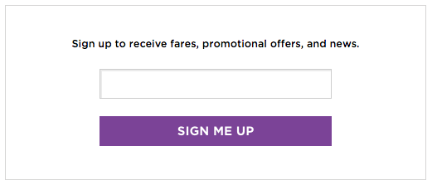   
Top Things To Do in Santa Barbara

With museums, parks, beaches and plenty more, there are many Santa Barbara attractions you’ll want to check out. Below are a few to put on your list for when you’ll be in this sunny, laid-back city.

* Admire the architecture at the Santa Barbara County Courthouse. When you see the intricate tile mosaics, gorgeously colorful gardens, and spectacular view of the city and ocean below it, you’ll understand why it’s considered one of the most beautiful government buildings in America. Be sure not to miss the Mural Room and the El Mirador clock tower!
* Head to the Santa Barbara Arts and Crafts Show. Held every Sunday, up to 200 local artists partake in this widely popular art show, which runs along more than half a mile of beachfront on Cabrillo Boulevard. With jewelry, paintings, pottery, sculpture, photography and much more, you’re sure to find something you love while strolling along.
* Spend a relaxing day at East Beach. A bit more removed from the downtown area than other beaches, East Beach doesn’t get as crowded – giving you more sand to truly enjoy some down time in the sun. Clean sand and free parking are extra bonuses.
* Experience the Santa Barbara Urban Wine Trail. Sample all the finest wines produced in the region, all within blocks of the beach. Don’t miss the chance to sip your way through a delicious selection of varieties and styles.

Travel Tips and Resources

[Must-Dos in Santa Barbara](http://travel.usnews.com/Santa_Barbara_CA/Things_To_Do)

[Santa Barbara Hotels](http://www.tripadvisor.com/Hotels-g33045-Santa_Barbara_California-Hotels.html)

[Santa Barbara Restaurants](http://www.tripadvisor.com/Restaurants-g33045-Santa_Barbara_California.html)

[Santa Barbara Shopping Guide](http://www.downtownsb.org/discover/shop-and-stroll)

[Santa Barbara Nightlife and Entertainment](http://www.10best.com/destinations/california/santa-barbara/nightlife)

[Santa Barbara Travel Tips](http://travel.usnews.com/Santa_Barbara_CA/Travel_Tips)

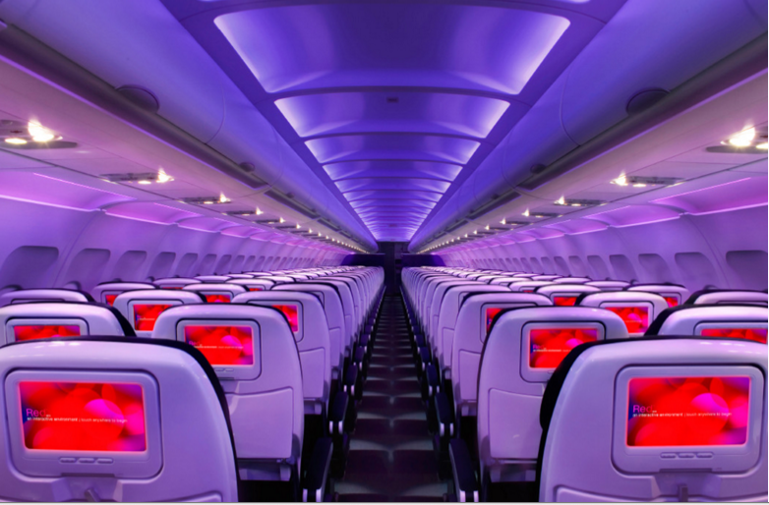

Main Cabin Main Cabin Select First Class

(add links to Cabin Class Pages)

Ready. Set. Fly.

Book your Mood-lit Ride to Santa Barbara.

Whether you’re visiting for business or vacation, you can book a flight to Los Angeles International with Virgin America. Rent a car for the scenic 2-hour drive from LA to Santa Barbara. Take the Pacific Coast Highway and stop in Malibu or Ventura. Fly with us and experience what it’s like to enjoy comfort and style in the sky. From custom-designed seats to on-demand food ordering, our amenities are in a class of their own.

Take a Virtual Tour

Add Terms & Conditions